WEB INTEGRATION:

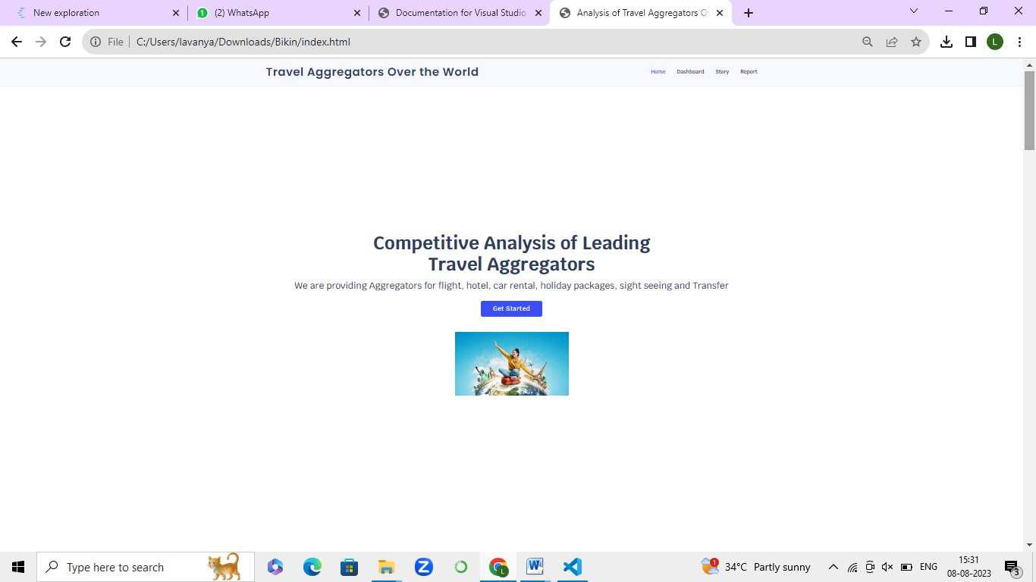

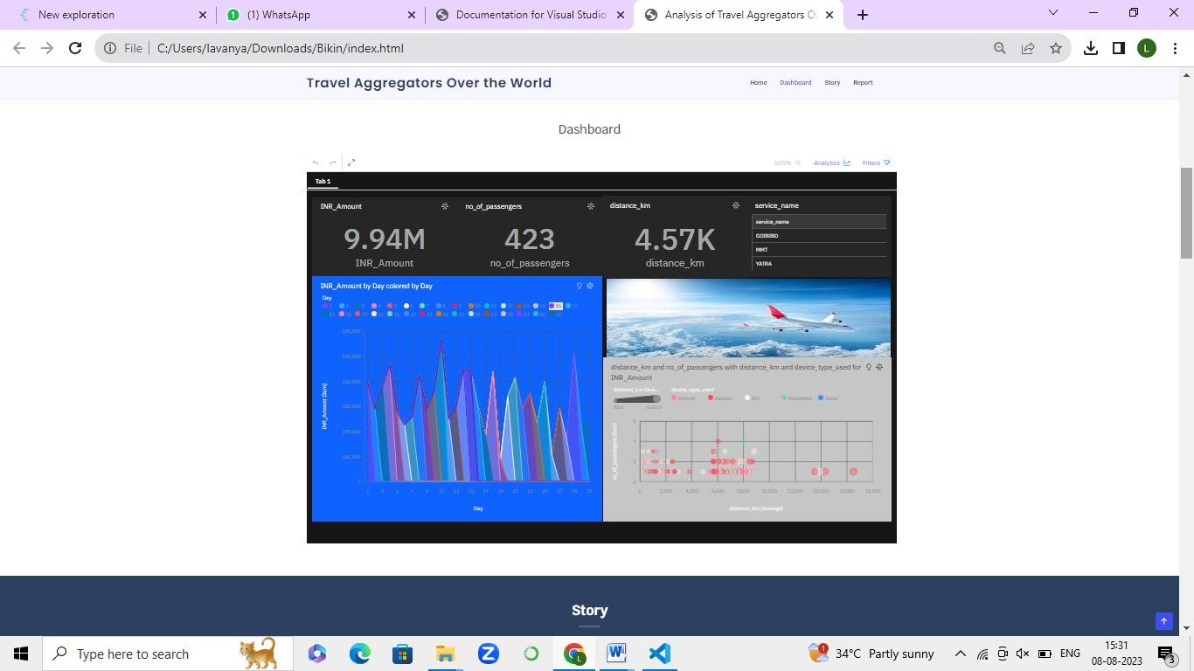

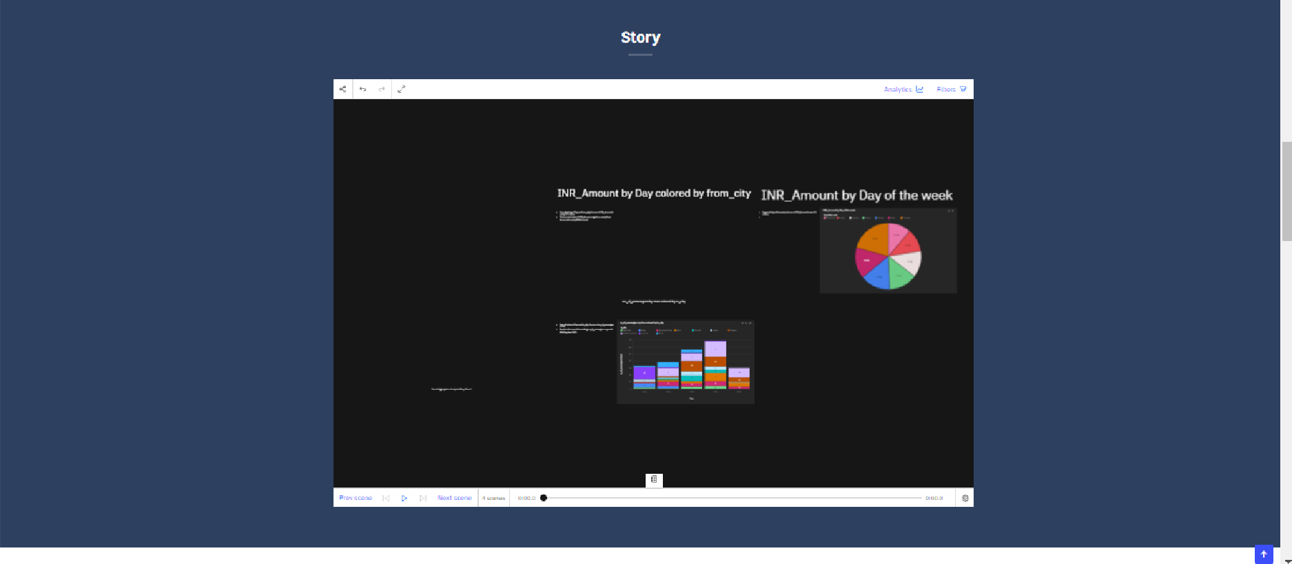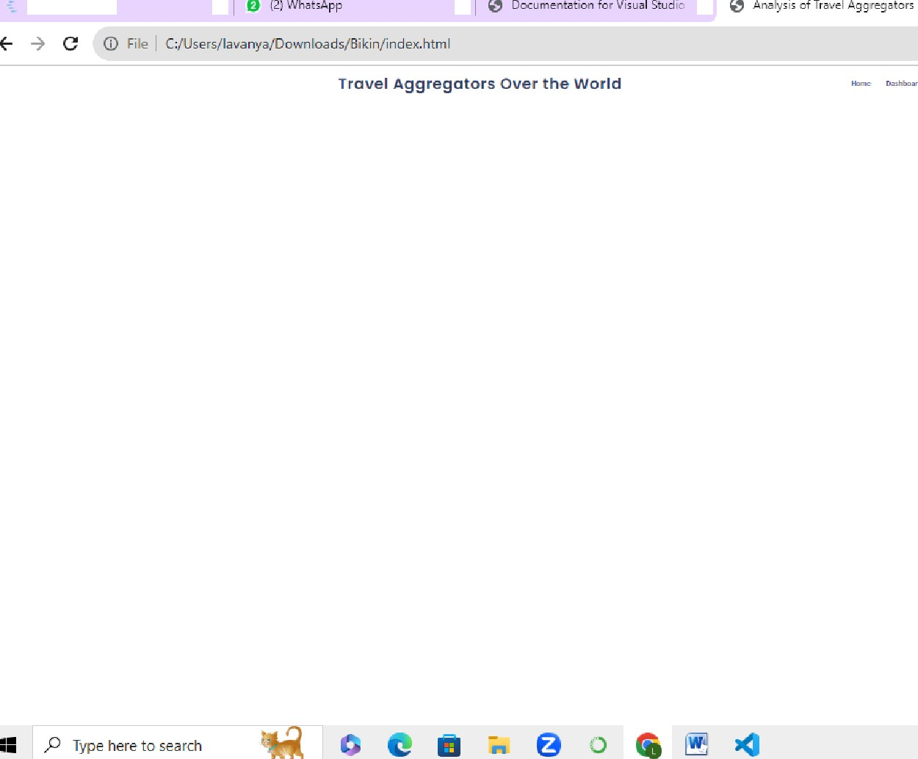

i} - ” C ''U e ' a on"- ' a \onI or ds. g iLin, index.h-i-n 1 6

Travel Ag gregators Over th e Wo rld

Report

